

## Product Dissection for Instagram

## Company

Instagram, established in 2010 by Kevin Systrom and Mike Krieger, has revolutionized the manner in which individuals engage, share, and discover visual content on the internet. Following its acquisition by Facebook, Instagram has evolved into a worldwide social media sensation, celebrated for its captivating interface and groundbreaking functionalities. Prioritizing visual storytelling and user involvement, Instagram has drawn in a vast global user base, solidifying its position as a top-tier platform in the realm of social networking.

### **Product Dissection and Real-World Problems Solved by Instagram:**

Instagram's innovative engagement tools, such as likes, comments, and personalized content recommendations via the "Explore" feature, have redefined how users interact with content. By addressing the problem of information overload, Instagram curates content that is relevant, helping users uncover new accounts, posts, and trends tailored to their specific interests. Additionally, Instagram's introduction of hashtags has revolutionized content discovery by enabling users to categorize their posts with keywords. This inventive approach efficiently handles the challenge of sifting through vast amounts of content to find pertinent information, simplifying the process for users to connect with content that aligns with their interests and engage in meaningful conversations.

Algorithmic Feed and Content Recommendation: Instagram's algorithm plays a pivotal role in shaping user experiences. The platform must strike a balance between enhancing user engagement and promoting responsible content consumption. Design considerations may involve fine-tuning the algorithm to prioritize meaningful content over addictive or sensational material.User Controls and Notifications: Instagram can empower users by providing them with more detailed control over their feeds and notifications. This can encompass features like setting time limits, categorizing content, and customizing notifications to reduce the constant feeling of being "plugged in."Digital Well-being Features: The incorporation of features that promote digital well-being is crucial. These may include daily usage statistics, reminders to take breaks, and options to mute or filter specific keywords or content types that could be distressing or triggering to users. These features can help users maintain a healthier relationship with the platform and the digital world in general.

Wellness Dashboard: Create a dedicated "Wellness Dashboard" within the Instagram app, offering users insights into their usage patterns. This dashboard could provide information on daily and weekly screen time, engagement metrics, and offer personalized recommendations for more mindful and healthier usage.Customizable Feed Algorithm: Empower users with greater control over their feed content. Allow them to fine-tune the content they see, including options to prioritize posts from close friends, mute content from specific users or categories, and set time limits for scrolling to curate a more personalized and balanced experience.Mindful Notifications: Implement an "Intelligent Notification" system that encourages users to take breaks and be more conscious of their social media consumption. These notifications could be batched or sent at intervals to reduce the constant interruption of users' lives, promoting a more mindful and less intrusive approach to notifications.

### **Case Study: Real-World Problems and Instagram's Innovative Solutions**

Instagram, a prominent social media platform, has not just transformed the manner in which we share and engage with content but has also effectively tackled substantial real-world challenges through its inventive capabilities. By recognizing the needs of its users and harnessing technology, Instagram has established itself as a solution-oriented platform that facilitates connections, promotes self-expression, and elevates the quality of digital interactions.

#### **Limited Personal Branding**

Problem 1: Restricted Personal Branding Real-World Challenge: Crafting a distinct online identity can prove difficult, especially on conventional text-based platforms that impose constraints on personal branding.

Instagram's Solution: Instagram provides users with an extensive profile area featuring a profile picture, username, bio, and highlights. This creative space enables users to visually convey their personalities and passions, effectively addressing the challenge of restricted personal branding encountered on traditional platforms.

#### **Information Overload**

Problem 2: Information Overload Real-World Challenge: The sheer volume of online content can inundate users, making it arduous to locate pertinent and captivating content that aligns with their interests.

Instagram's Solution: Instagram tackles the dilemma of information overload with its inventive "Explore" feature. Employing sophisticated algorithms, the platform assembles a personalized content feed tailored to each user's specific preferences. This intelligent content recommendation system guarantees that users come across posts, accounts, and trends that align with their interests, mitigating the issue of information overload and augmenting the user experience.

## Conclusion

In summary, the Insta Product Dissection Project, utilizing PostgreSQL in conjunction with an Enterprise Data Repository (EDR), has yielded valuable insights into the architecture of Instagram's product and its usage patterns. Leveraging PostgreSQL as the Relational Database Management System (RDBMS) has proven effective in storing and managing Instagram's data, thereby facilitating data-driven decision-making. The incorporation of an EDR has further bolstered data governance and security, guaranteeing the integrity and confidentiality of vital user and content information. Ultimately, this project has empowered the organization to make informed decisions and refine Instagram's product offerings, ultimately leading to enhanced user experiences and sustained growth.

## Key Features of Instagram:

* User Profiles: Instagram provides users with the ability to create personal profiles, offering insights into their lives through features such as usernames, full names, bios, and profile pictures. This allows for the creation of personalized online identities that reflect individual personalities.
* Posts: A fundamental aspect of Instagram is the ability to share photos and videos as posts. Users can enhance their content with captions, location tags, and creative tools such as filters and stickers, enabling them to express themselves visually.
* Interactions: Engagement is at the core of Instagram. Users can express their appreciation by liking posts and engaging in discussions through comments. The "Save" feature allows users to bookmark content for later reference.
* Followers and Following: Instagram encourages connections through the "Follow" function. Users can follow other accounts to have their posts appear in their feed, fostering a network of connections. Additionally, users can view who is following them, promoting transparency.
* Explore: The "Explore" feature facilitates content discovery by suggesting posts, videos, and stories based on user preferences and interactions. This allows users to explore content from accounts they don't follow, diversifying their online experience.
* Hashtags: Instagram pioneered the use of hashtags, which categorize posts and enhance discoverability. Users can add relevant hashtags to their posts, making them accessible to a broader audience and increasing their visibility.

**Schema Description:**

##### The Instagram schema encompasses various entities that depict different facets of the platform. These entities include Users, Posts, Comments, Likes, Followers, Hashtags, and more. Each entity is characterized by specific attributes that define its properties and establish connections with other entities, creating a comprehensive structure for organizing and managing data within the platform.

## Types Of Entity

##### Users form the foundation of Instagram, and the user entity contains essential information about each user:

##### UserID (Primary Key): A unique identifier assigned to each user.

##### Username: The selected username for the user's account.

##### Email: The user's email address used for account-related communication.

##### Full_Name: The user's complete name as it appears on their profile.

##### Bio: A concise description that allows users to express themselves. Registration_Date: The date when the user initially joined Instagram.

##### Follower Entity: Followers establish connections between users:

##### FollowerID (Primary Key): A unique identifier for each follower relationship

##### . FollowingUserID (Foreign Key referencing User Entity): Identifies the user who is being followed.

##### FollowerUserID (Foreign Key referencing User Entity): Identifies the user who is following. Follow_Date: The date when the following relationship was initiated.

##### Hashtag Entity: Hashtags categorize and group content:

##### HashtagID (Primary Key): A unique identifier for each hashtag. Tag: The actual text of the hashtag.

##### PostHashtag Entity: Associates posts with hashtags:

##### PostHashtagID (Primary Key): A unique identifier for each association.

##### PostID (Foreign Key referencing Post Entity):Identifies the post associated with the hashtag.

##### HashtagID (Foreign Key referencing Hashtag Entity): Identifies the hashtag associated with the post.

##### Comment Entity: Comments enable users to engage in conversations around

##### posts: CommentID (Primary Key): A unique identifier for each comment. PostID (Foreign Key referencing Post Entity): The post being commented on.

##### UserID (Foreign Key referencing User Entity): The user who posted the comment.

##### Text: The text of the comment.

##### Comment_Date: The date when the comment was posted.

##### Like Entity: Likes represent user appreciation for posts: LikeID (Primary Key): A unique identifier for each like.

##### PostID (Foreign Key referencing Post Entity): The post being liked.

##### USER ID(Foreign Key referencing User Entity): The user who liked the post. Like_Date: The date when the like was registered.

## ER Diagram

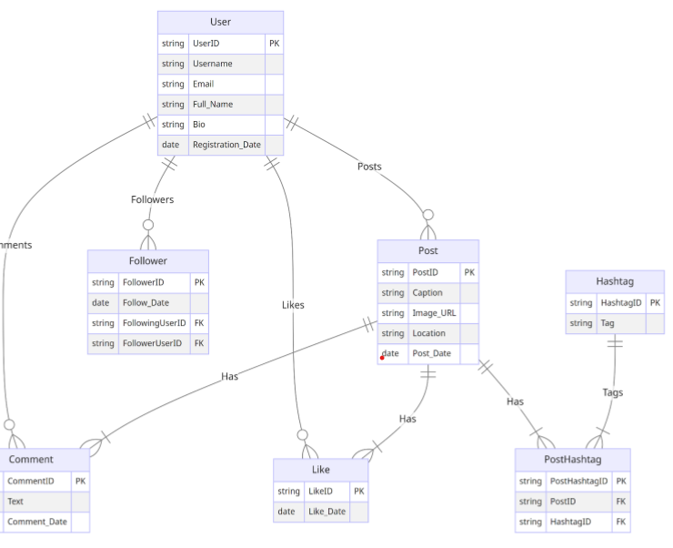

## Conclusion

In this case study, we explored the schema and Entity-Relationship diagram design of Instagram. Instagram has transformed the landscape of visual content sharing, promoting connections and artistic expression. The platform's intricate data model, composed of entities such as users, posts, comments, likes, followers, hashtags, and their associations, serves as the bedrock for its smooth operation. By comprehending this schema, we gain an understanding of how Instagram proficiently handles the intricacies of user interactions and content sharing, which has contributed to its widespread appeal and ongoing success in the realm of social media.